DIRECTIONS TO TRIAL

Take US Hwy. 30, (west from I-405 or US 30 bypass from I-5), to the Sauvie Island Bridge. Cross the bridge onto Sauvie Island and continue NW Sauvie Island Rd., pass the Cracker Barrel Market on left and travel west about 2 miles. At the “Y” in the road stay left. Approximately 8.5 miles from the market you will enter the Wildlife Area where the road becomes graveled. Continue on gravel road until you see the parking area for field trial grounds (approx. 8.5 mi from the store).

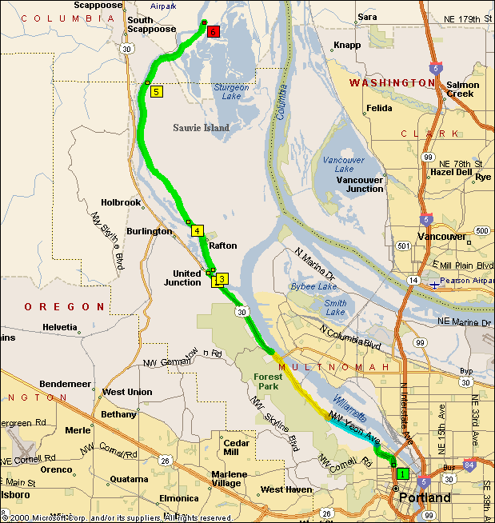

Event Number: 2022352202
OREGON GERMAN WIREHAIRED POINTER CLUB
WALKING FIELD TRIAL
SAUVIE ISLAND MANAGEMENT AREA (Crane Unit)
PORTLAND, OREGON
Aug 6-7, 2022

ALL STAKES OPEN TO ALL AKC POINTING BREEDS. Entries limited to 14 dogs in the AGD and OGD. WE RESERVE THE RIGHT TO CANCEL ANY STAKE WITH FEWER THAN 4 ENTRIES. BITCHES IN SEASON MAY COMPETE IN LAST BRACE OF OPEN DERBY. AKC APPROVED TRACKING COLLARS WILL BE PERMITTED.

THIS FIELD TRIAL IS HELD UNDER THE RULES AND PROCEDURES OF THE
AMERICAN KENNEL CLUB
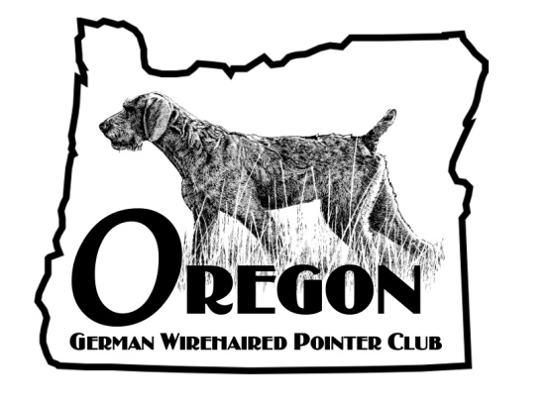

MAIL ENTRIES WITH CHECKS MADE OUT TO OGWPC TO:
Carolyn Griffith, FIELD TRIAL SECRETARY
16325 SW Colony Pl, Tigard, OR 97224
Email entries accepted
PHONE (503) 803-2219 CGRIFF0625@aol.com

ENTRIES WILL CLOSE AT 5:00 PM (PDT) Tuesday Aug 2, 2022
With the FIELD TRIAL SECRETARY AT
16325 SW Colony Pl , Tigard, OR 97224
Drawing will take place at 7:00 PM (PDT), Wednesday, Aug 3, 2022 at
13235 SW Bell Rd, Sherwood, OR 97140

FIELD TRIAL COMMITTEE
Ray Calkins, DVM-CHAIRMAN
Tom Higgins Carolyn Griffith Lynn Calkins Charlie Forth

CAPTAIN OF THE GUNS
Tom Higgins

STAKES, SCHEDULE AND ENTRY FEES

Open Puppy 7:00 am Sat. Aug 6, 2022 $55.00

Amateur Gun Dog (Ret) To follow Open Puppy $65.00
Open Gun Dog To follow AGD $65.00
Water Test To follow AGD $20.00
Open Derby To follow OGD $65.00

OFFICERS
CHARLIE CORRARINO, PRES 11935 SW Bowmont, Portland, OR
CHARLIE fORTH, VICE PRESIDENT, 2441 SE Wendy, Gresham, OR
LYNN CALKINS, SECRETARY/TREASURER, 13235 SW Bell Rd, Sherwood, OR 97140

Food: Water and beverages will be available. Please bring your own food.

Motels: Scappoose Creek Inn, Scappoose – 503-543-2740
La Quinta Motel, Portland – 503-497-9044
RV Park: Reeder Beach RV Park, Sauvie Island –
503-621-3098

Grounds: Overnight camping is not permitted. All vehicles must exit the parking area at the end of each day of the trial. A parking permit is required and may be purchased at the Cracker Barrel Store on the Island. One day charge is $15.00, or annually for $35.00. You may order your parking permit online at https://odfw.huntfishoregon.com/customer/catalog

JUDGES AND STAKES TO BE JUDGED

Sacha Woodward 2212 NW 379th St, LaCenter, WA 98629 OP,AGD,WT
Ed Woodward 2212 NW 379th St, LaCenter, WA 98629 OGD
Alen Braswell 1985 5th St, NE, Salem, OR 97301 AGD, WT
Mel Lueck 1265 NW 185th, Beaverton, OR 97006 OGD, OD
Jeff Calkins 885 Lund Ln, Baker City, OR 98489 OP, OD

COURSES AND BIRDS
ALL STAKES SINGLE COURSE WITHOUT A BIRDFIELD. CHUKAR, PHEASANT, AND/OR QUAIL WILL BE RELEASED IN ALL STAKES, EXCEPT OPEN PUPPY. NO BIRDS RELEASED IN OPEN PUPPY. AMATEUR GUN DOG WILL CALL BACK FOR RETRIEVE. A BLANK CARTRIDGE WILL BE FIRED IN OPEN/AMATEUR PUPPY. HORSEBACK HANDLING WILL NOT BE PERMITTED. ONLY JUDGES, BIRD PLANTERS, AND MARSHALS MAY BE MOUNTED.

PRIZES
STANDARD AKC ROSETTES TO ALL PLACED DOGS
A TROPHY WILL BE AWARDED TO FIRST PLACE IN EACH STAKE

ALL PARTICIPANTS, GUESTS & ENTRIES are accepted on the condition the Oregon German Wirehaired Pointer Club, its officers, officials, members and committee are released from liability for loss, damage or injury sustained by people, dogs or horses in connection with or during the trial.

OFFICIAL AMERICAN KENNEL CLUB FIELD TRIAL or HUNT TEST ENTRY FORM
Club:  Oregon German Wirehaired Pointer Club |  |  |  | Date:  Aug 6- 7, 2022 |  | Event #  2022352202
Location:  Sauvie Is. Mgmt. Area; Portland, OR |  | Event type(Trial or test)  Field Trial |  | Enter in Stake/Test:
BEAGLES

ONLY: Male Female 13” Class 15” Class
In Retriever Trials ONLY this dog is qualified for (circle answer):
Limited All-Age Stake YES NO Restricted All-Age Stake YES NO Special All-Age Stake YES NO
Foreign No.  AKC No. AKC Litter No. ILP No. & list country: |  |  |  |  | I enclose entry fees  In the amount of : $ |  |  |  | Call Name
Full Name of Dog:

Breed: | Reg. #: |  | Call Name : |  |  |  | Sex: | Date of Birth:
Sire:

Dam:

Name of Breeder:

Actual owner(s):

Owner’s Address:

City: State: Zip:

Name of Owner’s Agent/Handler:

Agent/Handler’s Address:

City: State: Zip:

AKC Rules, Regulations, Policies and Guidelines are available on the American Kennel Club website:www.akc.org
AGREEMENT
I certify that I am the actual owner of the dog, or that I am the duly authorized agent of the actual owner whose name I have entered
above. In consideration of the acceptance of this entry, I (we) agree to abide by the rules and regulations of The American Kennel Club in effect at the time of this event, and any additional rules and regulations appearing in the premium list of this event and entry form and any
decision made in accord with them. I (we) agree that the club holding this event has the right to refuse this entry for cause which the club
shall deem sufficient. In consideration of the acceptance of this entry and of the holding of this event and of the opportunity to have the
dog judged and to win prizes, ribbons, or trophies, I (we) agree to hold the AKC, the event-giving club, their members, directors, governors, officers, agents, superintendents or event secretary and the owner and/or lessor of the premises and any provider of services that are necessary to hold this event and any employees or volunteers of the aforementioned parties, and any AKC approved judge, judging at this event, harmless from any claim for loss or injury which may be alleged to have been caused directly or indirectly to any person or thing by the act of this dog while in or about the event premises or grounds or near any entrance thereto, and I (we) personally assume all
responsibility and liability for any such claim; and I (we) further agree to hold the aforementioned parties harmless from any claim for loss,
injury or damage to this dog. Additionally, I (we) hereby assume the sole responsibility for and agree to indemnify, defend and save the
aforementioned parties harmless from any and all loss and expense (including legal fees) by reason of the liability imposed by law upon
any of the aforementioned parties for damage because of bodily injuries, including death at any time resulting therefrom, sustained by any
person or persons, including myself (ourselves), or on account of damage to property, arising out of or in consequence of my (our)
participation in this event, however such, injuries, death or property damage may be caused, and whether or not the same may have been
caused or may be alleged to have been caused by the negligence of the aforementioned parties or any of their employees, agents, or any
other persons.
I (WE) AGREE THAT ANY CAUSE OF ACTION, CONTROVERSY OR CLAIM ARISING OUT OF OR RELATED TO THE ENTRY, EXHIBITION OR ATTENDANCE AT THE EVENT BETWEEN THE AKC AND THE EVENT-GIVING CLUB (UNLESS OTHERWISE STATED IN TIS PREMIUM LIST) AND MYSELF (OURSELVES) OR AS TO THE CONSTRUCTION, INTERPRETATION AND EFFECT OF THIS AGREEMENT SHALL BE SETTLED BY ARBITRATION PURSUANT TO THE APPLICABLE RULES OF THE AMERICAN ARBITRATION ASSOCIATION. HOWEVER, PRIOR TO ARBITRATION ALL APPLICABLE AKC BYLAWS, RULES, REGULATIONS AND PROCEDURES MUST FIRST BE FOLLOWED AS SET FORTH IN THE AKC CHARTER AND BYLAWS, RULES, REGULATIONS, PUBLISHED POLICIES AND GUIDELINES.
Signature of owner or his
Agent duly authorized to make this entry
Telephone: Email

OFFICIAL AMERICAN KENNEL CLUB FIELD TRIAL or HUNT TEST ENTRY FORM
Club:  Oregon German Wirehaired Pointer Club |  |  |  | Date:  Aug 6-7, 2022 |  | Event #  2022352202
Location:  Sauvie Is. Mgmt Area; Portland, OR |  | Event type(Trial or test)  Field Trial |  | Enter in Stake/Test:
BEAGLES

ONLY: Male Female 13” Class 15” Class
In Retriever Trials ONLY this dog is qualified for (circle answer):
Limited All-Age Stake YES NO Restricted All-Age Stake YES NO Special All-Age Stake YES NO
Foreign No.  AKC No. AKC Litter No. ILP No. & list country: |  |  |  |  | I enclose entry fees  In the amount of : $ |  |  |  | Call Name
Full Name of Dog:

Breed: | Reg. #: |  | Call Name : |  |  |  | Sex: | Date of Birth:
Sire:

Dam:

Name of Breeder:

Actual owner(s):

Owner’s Address:

City: State: Zip:

Name of Owner’s Agent/Handler:

Agent/Handler’s Address:

City: State: Zip:

AKC Rules, Regulations, Policies and Guidelines are available on the American Kennel Club website:www.akc.org
AGREEMENT
I certify that I am the actual owner of the dog, or that I am the duly authorized agent of the actual owner whose name I have entered
above. In consideration of the acceptance of this entry, I (we) agree to abide by the rules and regulations of The American Kennel Club in effect at the time of this event, and any additional rules and regulations appearing in the premium list of this event and entry form and any
decision made in accord with them. I (we) agree that the club holding this event has the right to refuse this entry for cause which the club
shall deem sufficient. In consideration of the acceptance of this entry and of the holding of this event and of the opportunity to have the
dog judged and to win prizes, ribbons, or trophies, I (we) agree to hold the AKC, the event-giving club, their members, directors, governors, officers, agents, superintendents or event secretary and the owner and/or lessor of the premises and any provider of services that are necessary to hold this event and any employees or volunteers of the aforementioned parties, and any AKC approved judge, judging at this event, harmless from any claim for loss or injury which may be alleged to have been caused directly or indirectly to any person or thing by the act of this dog while in or about the event premises or grounds or near any entrance thereto, and I (we) personally assume all
responsibility and liability for any such claim; and I (we) further agree to hold the aforementioned parties harmless from any claim for loss,
injury or damage to this dog. Additionally, I (we) hereby assume the sole responsibility for and agree to indemnify, defend and save the
aforementioned parties harmless from any and all loss and expense (including legal fees) by reason of the liability imposed by law upon
any of the aforementioned parties for damage because of bodily injuries, including death at any time resulting therefrom, sustained by any
person or persons, including myself (ourselves), or on account of damage to property, arising out of or in consequence of my (our)
participation in this event, however such, injuries, death or property damage may be caused, and whether or not the same may have been
caused or may be alleged to have been caused by the negligence of the aforementioned parties or any of their employees, agents, or any
other persons.
I (WE) AGREE THAT ANY CAUSE OF ACTION, CONTROVERSY OR CLAIM ARISING OUT OF OR RELATED TO THE ENTRY, EXHIBITION OR ATTENDANCE AT THE EVENT BETWEEN THE AKC AND THE EVENT-GIVING CLUB (UNLESS OTHERWISE STATED IN TIS PREMIUM LIST) AND MYSELF (OURSELVES) OR AS TO THE CONSTRUCTION, INTERPRETATION AND EFFECT OF THIS AGREEMENT SHALL BE SETTLED BY ARBITRATION PURSUANT TO THE APPLICABLE RULES OF THE AMERICAN ARBITRATION ASSOCIATION. HOWEVER, PRIOR TO ARBITRATION ALL APPLICABLE AKC BYLAWS, RULES, REGULATIONS AND PROCEDURES MUST FIRST BE FOLLOWED AS SET FORTH IN THE AKC CHARTER AND BYLAWS, RULES, REGULATIONS, PUBLISHED POLICIES AND GUIDELINES.
Signature of owner or his
Agent duly authorized to make this entry
Telephone: Email

